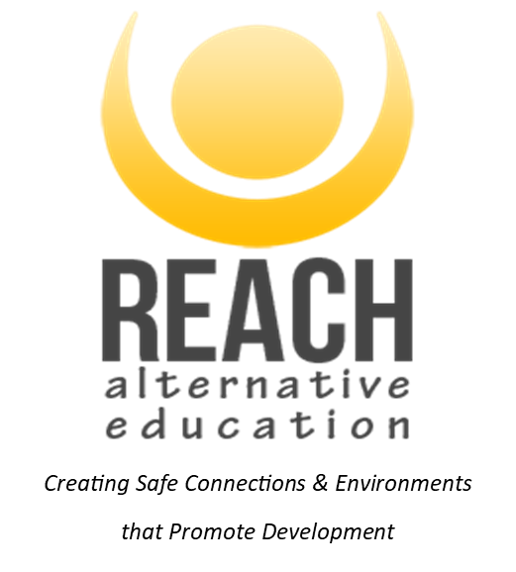

**PARENT/CARER CONSENT FORM FOR ALTERNATIVE PROVISION**

*This two-page form should be read with the accompanying information/letter about*

*the placement. All sections must be completed. Please answer with details or by stating N/A (Not Applicable) for the medical and dietary sections. This information is requested to enable staff to be fully informed and act in the best interest of all participants.*

**GENERAL INFORMATION**

**Name of Young Person:**…………………………………………………………………………….………………………………………………………………………………..……………………………………..

**Date of Birth:**……………………………………………………………………………………………………………………………………………………………………………………………………………………..…….

**School / Establishment:**………………………………………………………………………………………………….………………………………………………………………………………………………….

**Date(s) of placement:** September 2024 – July 2025

**Placement information**: *REACH Alternative Education placement, forming part of education provision for the student. Youth Work team, providing one to one and group placements, offsite from school, using one of REACH’s bases across Somerset. Using Youth workers cars as transport, and a wide range of activities including group work, mentoring, life skills, outdoor education sessions, visits to sites / public amenities and activity providers across the South West of the UK. See supplied list of activities and objectives to be worked on. Please contact REACH directly to discuss activities and programme content / should you wish to arrange a visit.*

**MEDICAL INFORMATION**

If the Young Person has any **condition** or **impairment** that may require **specific management**, **medical treatment** and/or **medication** during the outlined activity/trip/visit please give brief details below:

………………………………………………………………………………………………………...………………………….……………………………………………………………………………………………………………………

………………………………………………………………………………………….………………………………………….……………………………………………………………………………………………………………………

If the Young Person has any **allergies** or is **allergic to any medication** please supply details below:

…………………………………………………………………………………………………………………………………………………..………………………………………………………………………………………………………

……………………………………………………………………………………………………………………………………………………..……………………………………………………………………………………………………

If the Young Person has had any **recent illness**, **accident** or **injury** which staff should be aware of please supply details below:

…………………………………………………………………………………………………………………………………………………..………………………………………………………………………………………………………

……………………………………………………………………………………………………………………………………………………..……………………………………………………………………………………………………

Date of the Young Person’s **last anti-tetanus injection**:…………………………………………………………………………………………………….………………………….…….

Can the Young Person **swim**? ………………………………………………… Height:………………………………………………………………………………………………

GP Surgery…………………………………….………………………………………………… Telephone Number……………………………………………………………………………………………..

Address…………………………………………………………………………………………………………………………………………………………………………………………………………………………………………

**EMERGENCY CONTACT**

Name of Parent / Carer:.………………………………………………………………….…………………………………………………………………………………………………………………………..….…

Address:………………………………….………………………………………………………………….……………………………………………………………………………………………………………………………….

Emergency Telephone Number

Daytime:………………………………………………………………………………………… Evening time:….………………………………………………………………………………………………………

Please provide two **alternative emergency contacts** should parents/guardians not be available:

**1.** Name:…………………………………………………………………………….… Relationship to Young Person:…………………………………………….…….……………..……………

Address:……………………………………………………………………………………………………………………………………………………………………………………………………………………………………

Emergency Telephone Number

Daytime:………………………………….…………………………………………………………… Evening time:………...…………………………………………………………………………………………

**2.** Name:…………………………………………………………………………….… Relationship to Young Person:…………………………………………….…….……………..……………

Address:……………………………………………………………………………………………………………………………………………………………………………………………………………………………………

Emergency Telephone Number

Daytime:………………………………….…………………………………………………………… Evening time:………...…………………………………………………………………………………………

**DIETARY INFORMATION**

If the Young Person has any **essential dietary requirements**, please supply details below:

…………………………………………………………………………………………………………………………………………………..………………………………………………………………………………………………………

……………………………………………………………………………………………………………………………………………………..……………………………………………………………………………………………………

***If you feel that further detail or a discussion is required regarding any of the information that you have supplied, please contact the REACH prior to the start of the placement.***

**DECLARATION**

*I understand that all reasonable care will be taken of the Young Person during the placement and that they will be under an obligation to follow all directions and instructions given and observe all rules and regulations governing the placement and activities.*

*I understand that if the Young Person is a cause of danger to themself or to others, then they may be sent home early from the placement day. In such a situation you and the school will be notified first.*

*I understand the extent and limitations of the insurance cover provided and whilst the establishment staff in charge of the group will take all reasonable care, they cannot necessarily be held responsible for any loss or damage suffered by the Young Person during the visit. I understand that all visits are covered by public liability insurance and I can contact the school/ REACH if I require further details. Please note that the personal accident cover is not included in the cover provided by the school / REACH. It is the responsibility of the Parent / Carer to take our suitable personal accident cover, should they require it.*

*I agree to the Young Person receiving medical care if required. This would include first aid and any emergency dental, medical or surgical treatment as considered necessary by the medical authorities present in the best interest of your Young Person.*

*I give permission for the Young Person to be photographed/film during this visit/activity (for possible use in displays/presentations, marketing materials for sending to the school).*

*If you* ***do not*** *give permission for photos to be taken please tick this box*

*Having been informed through the details supplied. I consent to the Young Person taking part in this placement. This includes consent for them to take part in all of the outdoor activities, group work, one to one support and car travel opportunities supplied by REACH.*

Full name of Parent / Carer (print please):…………………………….…………………………………………………………………………………………………………………………..….…

Signed:………………………………………………………………………….……………………………………………………….… Date:…………………………………………….…….……………..…………………

**EXPLANATORY NOTES**

This form serves several important functions.

*1. It confirms your knowledge of and your agreement to the young person’s participation in the placement.*

*2. It gives the supervising staff immediate information on how to contact you in an emergency.*

*3. It contains information about the young person together with your consent to medical treatment if required.*

*4. It advises you that REACH will NOT necessarily be legally liable for every type of loss suffered by a child whilst on a visit.*

*5. The completion and returning of this form is essential to enable the young person to participate in the placement.*

*6. If you wish to discuss any of the contents of this form please contact the Director of REACH.*

*Last Updated: August 2024*